POPs
Protect Our Preserves San Diego

www.protectourpreserves.org
info@protectourpreserves.org
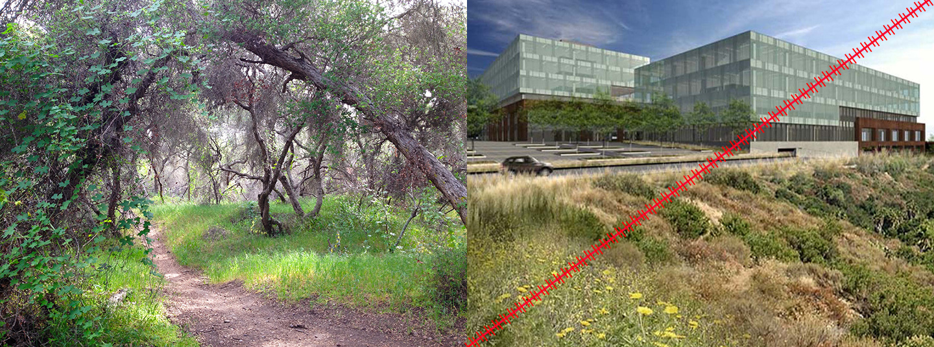

The Project:
A 450,000 square foot office campus on 11-acres, surrounded on three sides by the 900-acre Del Mar Mesa Preserve consisting of 3 buildings comprised of 4, 5 6 stories, a one story amenity building and a 7 story parking structure.

Current Zoning:
CL (Commercial Limited). The project requires a rezone from AR-1-1 (agricultural-residential effectively one house) to IP-3-1 (Industrial Park) and requires a General Plan Amendment, Community Plan Amendment to the Torrey Highlands Subarea Plan, Site Development Permit, and Planned Development Permit to change zoning to IP-3-1.

Del Mar Mesa Preserve:
The 900-acre Del Mar Mesa Preserve lies on the east end of Del Mar Mesa, west of Rancho Penasquitos and South of Torrey Highlands. It is protected under the city's Multiple Species Conservation Plan. Parts of the Preserve are under State, City and Federal jurisdiction. Home to dozens of endangered and threatened species of plants and animals, some unique to San Diego, the Preserve is also home to many vernal pool complexes. The Preserve is connected to Los Penasquitos Canyon and serves as a critical animal migration corridor for the City and County.

A popular recreational destination for equestrians, trail bike riders, naturalists and hikers, the City Parks Department developed a Resource Management Plan to designate compatible trails in consultation with community, environmental and recreational user groups that was enacted by the San Diego City Council.

Historical Context:
Del Mar Mesa Preserve is a City of San Diego resource-based park, created over twenty-five years through the combined efforts of US Fish and Wildlife, CA Fish and Wildlife, San Diego County, the City of San Diego, environmental groups both large and small, individual developers, property owners who dedicated up to 75% of the land in exchange for density, and hundreds of citizen volunteers, including among many others, Endangered Habitats League, Center for Biological Diversity, Sierra Club, Del Mar Mesa and Carmel Valley Planning Boards. and Friends of Los Penasquitos Canyon. The route for SR56 was planned to avoid the future preserve.

In 1990s, when the City’s MSCP boundaries were under discussion, the 11-acre site was excluded because it was a religious holding. The Catholic Diocese subsequently purchased it in 1999 after the passage of Proposition M in 1998. The Church village-like development proposal, approved in 2004, was low-rise and made up of different shapes and sizes of buildings interspersed with open space and was viewed as a community benefit by the Rancho Penasquitos community.

Planning Board Response:
Planning Boards are the official advisory bodies to the City of San Diego Planning Commission and the San Diego City Council. The Rancho Penasquitos and Del Mar Mesa Planning Boards voted unanimously to oppose the project due to its massive University City size/proportions and irrevocable intrusion into Del Mar Mesa Preserve.

DEL MAR MESA PRESERVE

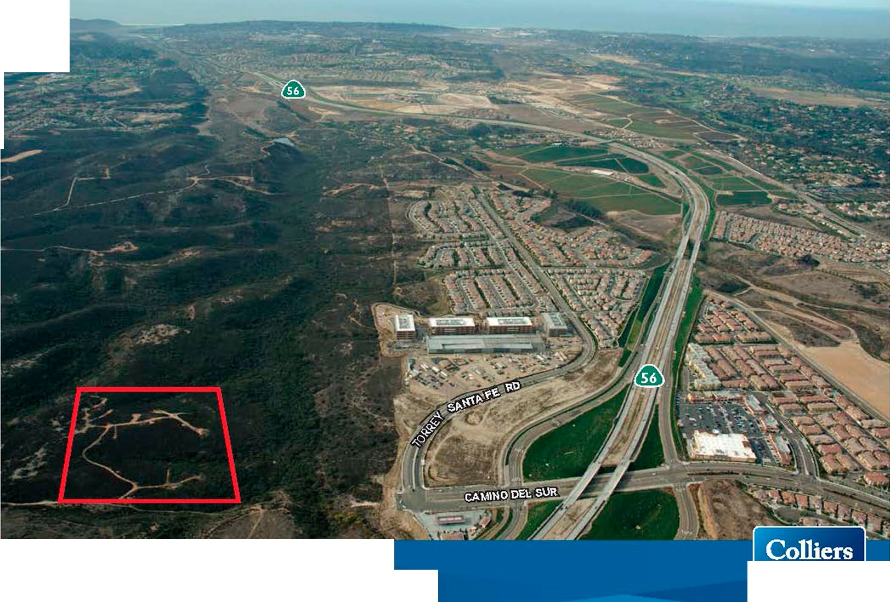
.
---.--='
'"';..,:.: :..:."·
CAMINO DEL SUR > CATHOLIC ARCHDIOCESE
INTERNATIONAL
Colliers Inte rnational Acceleral ing sLJCce ss. WMw .colliers.com

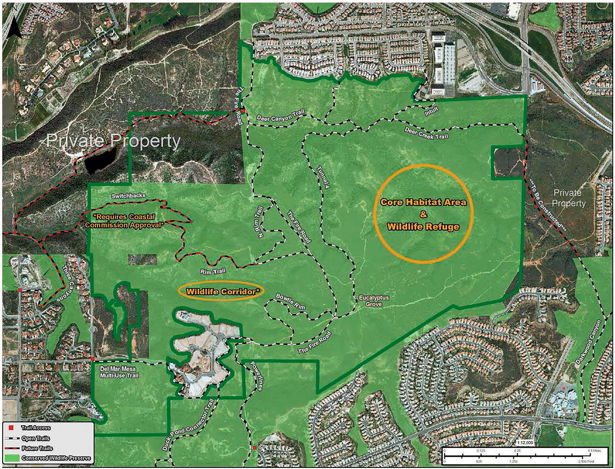

TRAIL MAP FROM THE DEL MAR MESA/CARMEL MTN PRESERVES
MANAGEMENT PLAN

PROPOSED PROJECT: PRESERVE AT TORREY HIGHLANDS

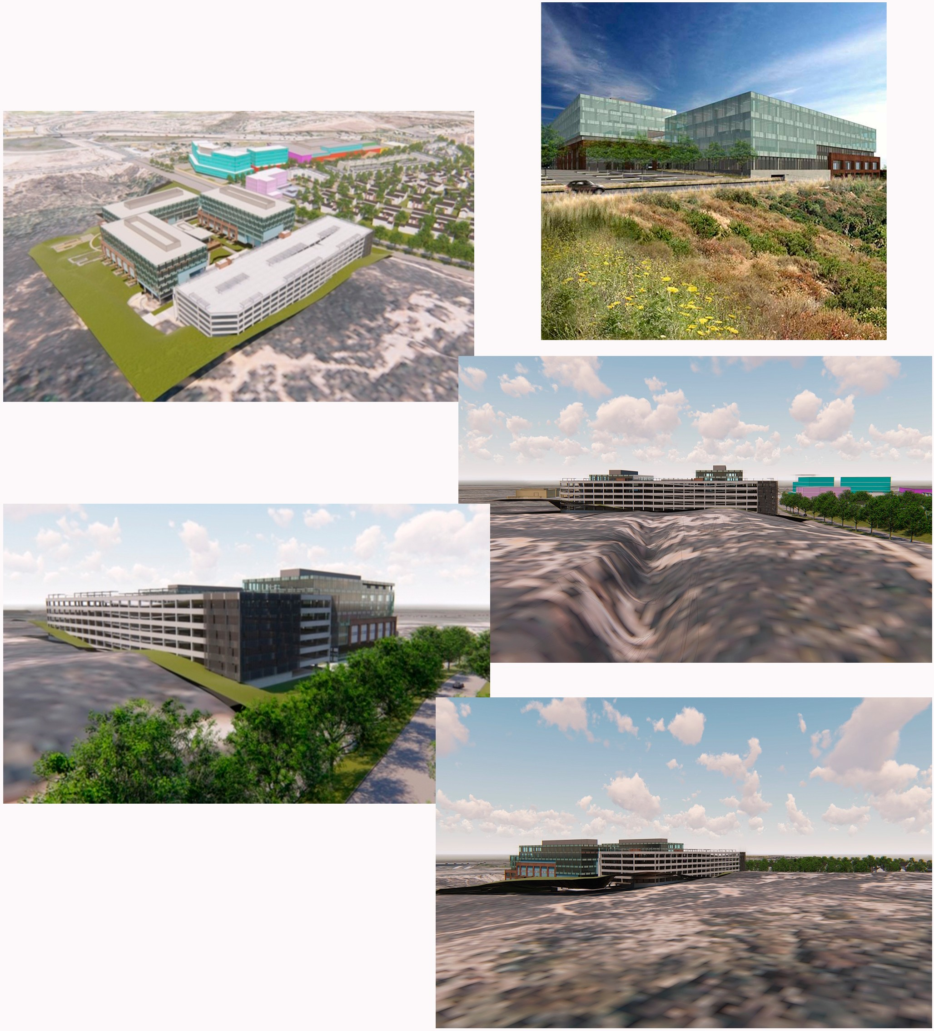

DEL MAR MESA PRESERVE: HABITAT, RECREATION, EDUCATION

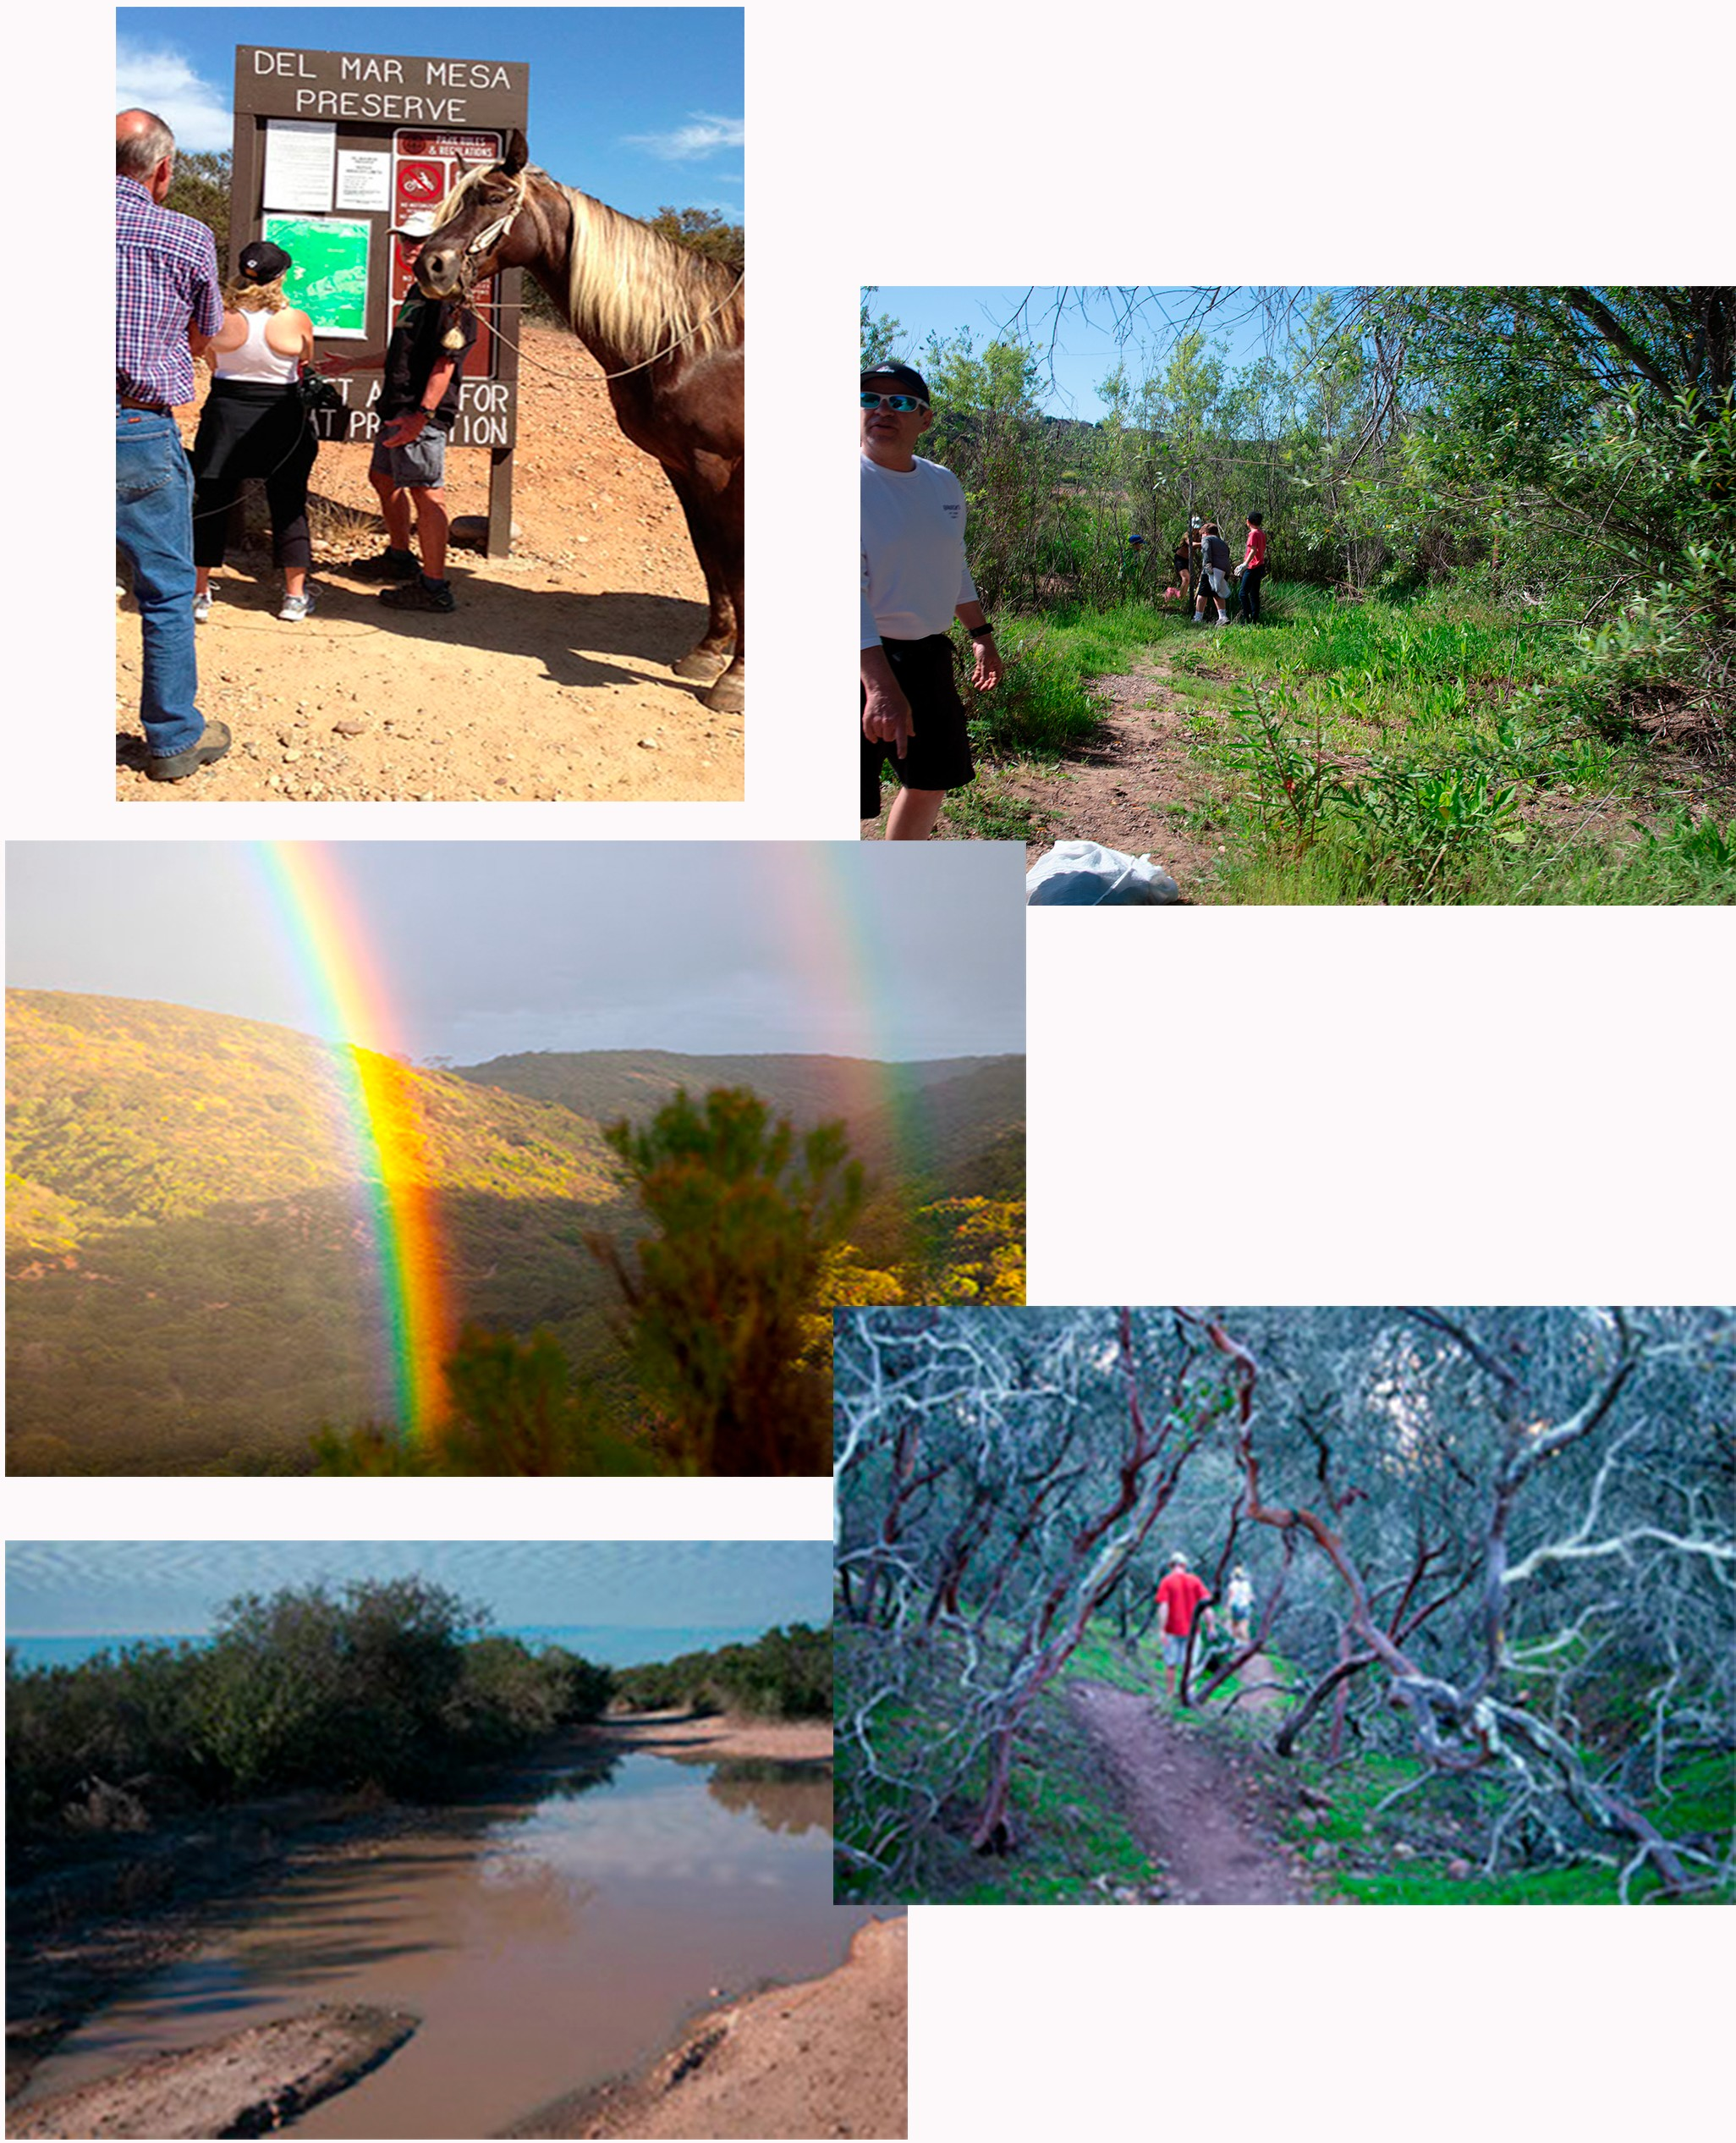

RANCHO

RANCHO PENASQUITOS PLANNING BOARD

- v ­
PENAsQu ,,.os

Mr. Stephen Haase, Chairperson
City of San Diego Planning Commission 1222 First Ave, Fifth Floor
San Diego, CA 92101 February 4, 2019

RE: THE PRESERVE AT TORREY HIGHLANDS - Project #442880
Final Action Taken by The Rancho Pei\asquitos Planning Board

Dear Chairperson, Haase,

The Rancho Penasquitos Planning Board (RPPB) is an advisor to the City in actions that would affect our community. On November 7, 2018, the RPPB held their monthly meeting in a public setting to address the proposed Preserve at Torrey Highlands SOP/rezone Project #442880 as an Agenda Action Item. The item was heard with a final vote to disapprove the project as presented (0.12-2-2).

We believe the present day can't become a short -termist means to become a long-term negative impact on those surrounding the development and the greater community at large.

The proposed Project's scale differs from the Community Plan and should not be allowed. The community-at­ large and members of the RPPB have expressed via numerous comments that the project's: 1) square footage/community evacuation/massing/adjacencies/traffic, and 2) specifically asking what "value" this large­ scale office facility will bring to the community, specifically the existing surrounding residential community.

The Applicant, Cistera, presented an updated project at the November RPPB meeting requesting the RPPB to approve the project. Again, the community asked why the Developer was proceeding with such a large project In contradiction to the Community Plan and community input. The response was that the Enterprise Zone (E Zone) allows the scope of this proposed project.

The RPPB and community acknowledges some project alterations:(landscaping, small increase in building street setback, 7 levels in parking structure - not 8, and adding PV Panels on the top parking structure level. However, per the communities repeated requests, Cistera has not reduced the size of the project's scope:

Site of approx. 11.2 acres
- 450,000 Gross Square Feet of developed Office lease and support space
- Three separate Office Buildings (4 stories, S stories and 6 stories), configuration never changed
- Eight level parking structure reduced to seven levels

Subterranean parking below two office buildings
- Landscaping design to mimic the surrounding natural preserve

The Rancho de /os Peiiasquitos Planning Board has been farmed and recognized by the San Diego City Council to make recommenda tions to the City Council, Planning Commission, City staff, and other governmental agencies on land use mailers, specifically concerning the preparation of. adoption of. implementation of, or amendment(s) to the General Plan or any land use plan when a plan relates to the Rancho Peiiasquitos, Torrey Highlands and Black Mountain Ranch communities ' boundaries. The planning group also advises on other land use mailers as requested by the City or other governme nlal agen cies.

At the November Board Meeting Cistera informed the community that after their Project is approved and built, the Developer will contribute $100,000 over 10 years to the local YMCA for capital improvements. If not approved the offer goes away. Some of the Board Members questioned the applicant's intent and ethics.

I will highlight several of the continuing conflicts between the Applicant and Planning Board. The RPPB members do not feel most of these concerns have been addressed to a mutual satisfaction.

Developer's goal is to use the site as: employment center urban design policy in the suburban plan.

The Developer stated they received the Planning Commission's approval to explore the viability of a Project with various goals/objectives needed to validate their design solutions:
- The provisions to assure that the project meets the Community Character
- Does not encroach onto the Habitat Management Planning Area
- Is consistent with land use agency guidelines
- The Planning Commission directed the Cistera to look at the adjacent proposed projects {Merge 56 & Rhodes Crossing) comprehensively and examine how they will interact with one another and encourage energy between each other.

"Prior RPPB Meeting Minutes of Sept. 4, 2013, page 5 of 10, and per the Planning Commission's direction to the Developer, Cisteria, was to look at the adjacent proposed projects {Merge 56 and Rhodes Crossing) comprehensively and how they will interact with one another and the energy between them". This issue has been a fundamental concern from RPPB's very first discussions with Cistera. The Development team was asked in several meetings if they had reached out and coordinated their project with the adjacent developers. There are differing views as to what extent of discussions/input/strategies have been discussed between parties.

Urban design is assimilating various pieces to make up the whole (buildings, streets, open spaces, parks, parking), especially based on how a human mind reacts to built forms. The proposed project Is excessive relative to the scale of the existing open space, residential community and proposed adjacent mixed-use project. No supporting documentation was presented addressing how the proposed project's mass, height, separation from adjacent buildings, property edge design, population density impact, traffic volumes etc., will not negatively affect occupants and users In the adjacent properties.

The EIR addressed the communities need to have "...new developments maintain or enhance the quality of life In the su"aundlng community. These elements are a pan of the Community Plan ta provide a policy direction ta maintain zoning and policy consistency, balanced communities, equitable development and en11lranmental justice..." The above italicized wording is from the City of San Diego General Plan.

LAND USE AND THE COMMUNITY PLAN:
Torrey Highlands Community Plan: The RPPB members understand their first Role and/or Function Is to assure each individual development conforms to the Community Plan as well as the General Plan Guidelines.

The Torrey Highlands Community Plan identifies the use of the site for Religious facilities, trade schools, storage, veterinary clinics, nurseries and garden centers. Cistera notes their design is guided by the City of San Diego General Plan. The current parcel is designated Commercial Limited (CU and zoned AR-1-1 with permitted uses to
include development of single-dwelling-unithomes at a required minimum ofS-10-du/ocre or agricultural uses
limited ta those oflow intensity ta minimize the potential conflicts with residential uses. The proposed project, based on a requested Zone Change, allows 450,000 square feet of commercial use with an approx. 160,000 square foot 7 level parking structure with additional parking below two buildings in addition to on-grade parking.

The below diagram and text block are from the Torrey Highlands Subarea Plan. The only area designated "CL" is the site of the proposed Preserve at Torrey Highlands project. The adjacent "CR" area is the Merge 55 Project
{Mixed-Use) site and the lower 2 triangular areas (gold) will be developed as Rhodes Crossing (Housing).

Pagel of 5

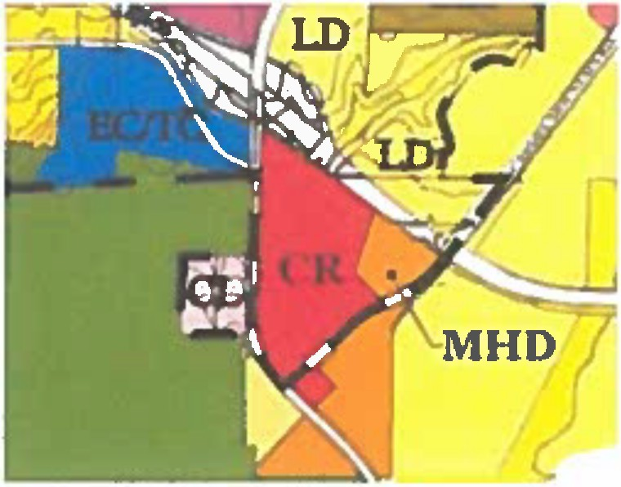
CL I Commercial Limited

Com.mercutl Lunited (CL)
Religious filcildies, trade schools, storage, veterinary cluucs, nurseries and garden centers.
- Discretionary re.iew to ensure compatibility uith adjacent Deer Canyon.

The above segment from the Torrey Highlands Subarea Plan cites "CL Uses" are recommended project types. These uses also reflect developments that would have less impact to the site, and the immediate community and beyond to the wider community, while complimenting the existing development.

Therefore, the size and density of the site are not compatible with the adjacent, walkable development.

Therefore, community and Board Members have asked the developer why they feel their project conforms. The Developers response was that via the Community Plan Amendment process they seek a zone change to allow an Enterprise Zone project as advocated by the City of San Diego. It was noted that this change of use will take precedent over the language of the Community Plan. If this is true, then in fact this project's planning premise Is based on having the General Plan support the project while Ignoring and overriding the Community Plan.

Within the DRAFT EIR, the "Land Use and Community Planning Element" addressed the community need to have development maintain or enhance the quality of life in the surrounding community. These elements are a part of the Community Plan to provide a policy direction to maintain zoning and policy consistency, balanced communities, equitable development and environmental justice. The above wording is from the City of San Diego

General Plan. The Community and Planning Board DO NOT understand nor believe the Preserve Project has presented data to show an enhancement to the 0 Qua fity of Life* within the surrounding community. As no mass transportation exist or is in future planning, the Project will primarily serve as an 8am to 5pm Office Use for a transitory population and thus not providing an enhancement to the community.

Value/Benefit brought to the Community
The development team has been asked several times to provide details regarding the value and benefit this scale and use of a project brings to the community. The Developer's response is that developing the site as an Enterprise Zone Use will bring more individuals to the area to support the commercial interests of the community, specifically the adjacent Merge 56 project. The Community feels this injection of daytime users is not an equitable

justification to support this scale of a development relative to the impacts imposed on the community.

Because an amendment to the Community Plan requires the proposed project to provide additional public benefit to the community as compared to the existing land use designation (CL to EC), the provided benefit should be measured within the Jurisdiction of which the Community Plan covers: in this case the current residents of Torrey Highlands and the edge of Park Village. Cistera's response to the question of benefit to the community is based
on an expected benefit to commercial interests, that do not appear equitable. There should be a measurable benefit to the existing community. The applicant has stated that their project helps support the adjacent Merge

Page 3of 5

56 project, however, does not directly provide a benefit to the surrounding community- only to the future development.

Proximity to adjacent properties
It has been presented by Ostera that an economic gain for the community will be realized, noting the Office space occupants will dine and shop at the adjacent Merge 56 facilities. This is understood for dining and minor shopping. Almost all Office Space users will be commuters. The economic impact will be very small for evening and weekend shopping. The Board's understanding is that the presented scenario has no economic modeling to support economics as a reason to approve the project.

Merge 56 Residential Project
The Merge 56 project includes approximately 500,000 sq. ft. of Office and Retail space and 242 residential units. The Cistera project which proposes approximately 450,000 sq. ft. of Office and 180,000 sq. ft. for parking on 11.2 acres. The siting of three Cistera Project office buildings and parking structure directly west of Merge 56 will block sunlight to commercial and future residents in buildings directly across Camino del Sur.

Rhodes Crossing Residential Project
Project is still in the design stages. This project proposes a residential project with two-and three-story structures. Based on its lack of direct adjacency to the Preserve Project site the visual impacts will be affecting this project as well. That is, the two projects have not been coordinating the impacts of their respective developments.

Draft EIR Document comments addressing various Impacts
The ElR cites justifications to support this development. To be a fair and equitable EIR, the text and supporting documents need to completely address the project's relationship and compatibility to the larger community and not just the project's site. The Developer and EIR do not provide adequate justification to support this development.

The Preserve Project's EIR and their "Project Objectives" are flawed In stating this project provides a cohesive design that is compatible in scale and character to other existing and planned development within the adjacent vicinity. The only existing and proposed commercial/office planning area is directly adjacent to the SR 56 Freeway corridor. The proposed project site ls not contiguous to SR 56 and is physically separated from all other higher density Office Facilities along Torrey Santa Fe Road. The Preserve's project scope is exactly what the vacant property along Torrey Santa Fe Road is Zoned for. Therefore, why place the Preserve Project's additional office buildings across from residential uses when there is vacant commercial property that currently isn't marketable?

Cistera needs to provide supporting documentation based on known facts to support the EIR statement on Page 3· 1, Section 3.2, bullet 4 stating that multimodal transportation linkages will be Implemented to offset what will be a transportation critical mass at Camino del Sur and State Route 56. Project should be conditioned to have viable implemented multimodal transportation linkages prior to occupancy of any commercial spaces.

Chapter 4 "History of Project Changes" notes several sites and building plan changes (majority regarding traffic) which are based on functional needs to solve technical requirements. The community in several public meetings has requested the developer to address spacial cognition: (a sense of place; acoustical concerns; visual perception; the sense of space, etc.) to support the community with a project that is successful for the community, not just the developer. The community asks why only the technical issues were being addressed in the project's design and not the requests from the community residents, and there was no response.

Potential Impacts to safe evacuations due to Wildfires
In a wildfire crisis, the office workers, Merge 56, future Rhodes crossing, and Park Village residents will need a demonstrated evacuation plan. The existing office complex in the EC/TC Zone and adjacent residential development can only evacuate using Torrey Santa Fe Road to Camino Del Sur north of the Preserve Project. The

Page4of 5

large number of individuals evacuating the Preserve project will become congested at the intersection of Torrey Santa Fe Road and Camino del Sur. The Park Village resident's evacuation route will be highly impacted.

In Summary, the Community and Planning Group's Comments Are:
  - The Planning Board is charged to maintain the Integrity of the approved Community Plan.
  - One community concern is that the initiation of the Community Plan Amendment is to re-designate the site from Commercial Limited to an Employment Center. The RPPB strongly objects to this project without adequate documents to support how this project positively enhances the community.
  - We ask the Planning Commission Members to support the Planning Board in protecting what the community has rather than looking for a Project to promote an image outside the approved guidelines of our Community/Subarea Plans.
  - The RPPB has stated the development of 450,000 square feet of commercial office space in multiple midrise buildings with a seven-level parking structure does not embrace the Intent of the Subarea Plan.
  - The Community and the RPPB DO NOT understand nor believe the Preserve Project has presented data showing any enhancement to the "Quality of llfen within the surrounding community. No mass transit currently exists, and nothing is in future planning.
  - The RPPB believes the proposed project does not meet the criteria for Initiation of Amendment citing no additional public benefits for the residents ofTorrey Highlands and Rancho Penasquitos.
  - The proposed project site Is not contiguous to SR 56 and other high- density Office Facilities along Torrey Santa Fe Road. The Cistera site is almost adjacent to vacant EC/TC property along Torrey Santa Fe Rd. Therefore, we question why not develop the Cistera Project on vacant property on Torrey Santa Fe Road?
  - The economic impact will be very small for evening and weekend shopping. The Boards believes that the idea has no data to support the Project's economic Input as being a reason to approve the project.
  - At the CPA Initiation hearing the Planning Commission asked Cistera: "How does the approval of this
Project as presented energize our community by building what the site will allow (based on traffic analysis defining the maximum number of automobiles remaining for build-out)?" Based on the information provided, the community does not feel adequate material has been presented to develop a nexus between the Clstera Project, Rhodes Crossing and Merge 56.
  - Condition Project to have viable implemented multimodal transportation linkages operational prior to occupancy of any commercial spaces.
  - Assure that the Torrey Meadows community has a secondary means out, across SR 56 freeway for health
and safety.

We must avoid the short•termlst approach. Todays decision makers have a moral obligation to our future communities to openly discuss and make decisions where real existential risks to the community exist. The Community and members of the Rancho Penasquitos Planning Board sincerely appreciate your consideration to listen to our concerns and support the Community by acknowledging not all projects benefit the community.

Thomas W. Clark, A.I.A.
Chair, Rancho Peiiasquitos Planning Board

Copies to: Chris Cate, San Diego City Council, Sixth District Mark Kersey, San Diego City Council, Fifth District
Susan Peerson, Vice.Chairperson, Planning Commission Douglas Austin, Planning Commission Member
William Hofman, Planning Commission Member Vicki Granowitz, Planning Commission Member Dennis Otsuii, Planning Commission Member James Whalen, Planning Commission Member William Zounes, Development Project Manager RPPB Members
PageSof 5

Del Mar Mesa Community Planning Board
3525 Del Mar Heights Road, Box 246, San Diego, California 92130

City of San Diego Development Service Department 1222 First Avenue, MS 501
San Diego, CA 92101
c/o E. Shearer-Nguyen, Environmental Planner Re: The Preserve At Torrey Highlands/442880

The Del Mar Mesa Planning Board as an advisory body to the San Diego Planning Commission and San Diego City Council submits this letter, approved unanimously at the April 14, 2016 meeting, outlining issues that should be addressed in the Environmental Impact Study for the proposed development called The Preserve At Torrey Highlands.

Cisterra Development is seeking an amendment to the City’s General Plan and an amendment to the Torrey Highlands Subarea Community Plan to re-designate the project site from Commercial Limited to Employment Center, a re-zone from AR1-1 (agricultural or residential 1 per 10-acre lots) to IP-3-1 (industrial park) to construct a 450,000 square foot office complex on an 11-acre site formerly owned by the Catholic Diocese at the eastern end of Del Mar Mesa Preserve.

While the site is within the Torrey Highlands Community Plan Area, it is surrounded on three sides by Del Mar Mesa Preserve, which lies within the Del Mar Mesa Community Plan Area.

The proposed project will be visible from neighborhoods within Del Mar Mesa and is adjacent to popular undeveloped trails that connect to the 10-mile trail system within the community.

The Board commends San Diego City Staff for the comprehensive list of questions that the project applicant must answer about the environmental impacts of the project in the study.

However, the Del Mar Mesa Planning Board wants to ensure that the EIR details impacts to the Del Mar Mesa Community specifically, and more broadly, the cumulative effect on the larger ecosystem of interconnected habitat areas essential for the survival of Del Mar Mesa Preserve.

And so in addition to the issues outlined in the city staff EIR Scoping Document, the Board asks that the applicant describe the following.

1. Effects on the community character of Del Mar Mesa neighborhoods, including:
a. Visual impacts to homeowners in neighborhoods The Preserve, Bougainvillea, Duck Pond, Alta Vista, and future homes on the east end of the community. These should be outlined and graphic representations of those views included
b. Effects of noise levels and night lighting during daily operation
c. Noise and air quality during construction, including effects of exporting 63,000 cubic yards of soil

2. Compatibility with the Del Mar Mesa/Carmel Mountain Preserves Resource Management Plan, approved by the Del Mar Mesa Planning Board and San Diego City Council, which took over a decade to enact representing a compromise agreement between various recreational user groups, environmentalists, and state, federal and local park agencies:
a. Show that the same criteria for vernal pool avoidance required of trail planners by wildlife and park agencies when mapping the Resource Management Plan will be followed.
b. Identify any trails defined by the Management Plan that will be disrupted or blocked.
c. Describe impacts to the special trail “Tunnel 1” through Deer Canyon.

3. Del Mar Mesa and Del Mar Mesa Preserve are home to popular public biking, hiking and equestrian trails. Recreation should be deemed a significant area to review:
a. Visual graphics that clearly show what the project will look like from view points along the trail systems memorialized in the Resource Management Plan
b. Description of any additional stress on the trails both inside Del Mar Mesa Preserve and on the connected 10-mile public trail system within the Del Mar Mesa community
c. Disruptions to the quiet enjoyment of Del Mar Mesa Preserve and Los Penasquitos Canyon, should be part of any community character assessment, including but not confined to, noise and visual effects, loss of wildlife, and elimination of sensitive plants, during construction and from daily operation
d. Identify funding for affected trail maintenance

4. As stated previously, Del Mar Mesa Preserve is a functioning part of a larger interconnected ecosystem that includes Los Penasquitos Canyon, Carmel Mountain, Los Penasquitos Lagoon and Torrey Pines State Park. Therefore the following should be analyzed:
a. Cumulative impacts to the entire Preserve system.
b. Adjacency effects on protected Federal, State and City lands at the edges of the project, including vernal pools.

5. Community Benefit
a. Community Plan Amendments require that projects of this magnitude substantially benefit the community. Any of those benefits must be within the Torrey Highlands and Del Mar Mesa Community Planning Areas.
b. Benefits should substantially enhance the preservation goals of the Del Mar Mesa Preserve and the interconnected habitats of Los Penasquitos Canyon Preserve, Carmel Mountain Preserve, Los Penasquitos Lagoon and Torrey Pines State Park.

Finally, but no less important, is that higher uses than the proposed project are allowable if the applicant wins approval for a Community Plan and General Plan Amendment. Given the biological sensitivity and recreational popularity of Del Mar Mesa Preserve, along with direct and indirect on surrounding communities, the range of potential uses, facility density, and building heights should be made very clear to the public.

Respectfully,
Lisa Ross
Chair, The Preserve At Torrey Highlands Subcommittee Del Mar Mesa Planning Board

